**Pre-requisites:**

1. Hybris version 5.1
2. Storefront should be up and running preferably, electronic store

**Steps for installation:**

1. Unzip the attached zipped file and copy the contained extension in custom folder of hybris
2. Now perform following command to include and build data in the project.

*ant addoninstall -Daddonnames="dataremovaladdon" -DaddonStorefront.yacceleratorstorefront="<<storefront name e.g. bncstorefront>>"*

1. Include the following in localextensions.xml file:

<extension name="dataremovaladdon"/>

1. Run ant clean all. This will build the entire project once again including your module extensions.
2. Once the build is successful, start the hybris server using *hybrisserver.bat* command
3. Once the hybris server is started, then system update is required.

Update the hybris Commerce Suite

To finish the installation, you have to update the hybris Commerce Suite. During the update, the database tables, the type system, and the mandatory system data are created for the new addon.

1. Open the hybris Administration Console. The default URL for the hAC is http://localhost:9001.
2. You are prompted to enter a user account and a password.  
   By factory default, you can use the **admin**user account and the **nimda** password.

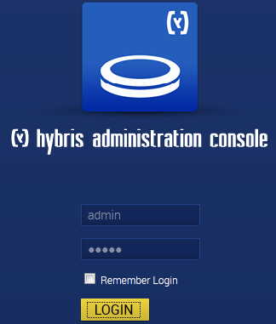

1. Go to the Platform tab and select Update option.

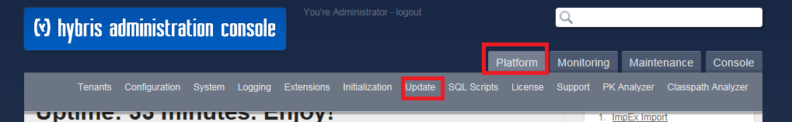

1. The Update page opens with preconfigured settings for update.
2. Deselect the checkbox stating “Create essential data”
3. Select the checkbox next to dataremovaladdon



1. Without changing any more settings, click the Update button. The update process starts and can take several minutes.
2. Once update is completed, click on continue button.
3. Go to HMC
4. Access HMC using url: [http://localhost:9001/hmc/hybris](http://10.168.138.15:2001/hmc/hybris)

Login: admin

Password: nimda

1. Click on Catalog -> Catalog Management Tools on left hand side navigation menu and click on “Synchronization”
2. A pop-up window will open. Select electronicsContentCatalog Staged->Target and click on Next
3. Click on start for starting the syncronization